Status Panels

Hew Lines VA7HU and Aki Yoshida JA1NLX

1.0 GENERAL

Logger32 provides two user-selectable ( Upper and Lower ) Status Bars. The display of these status bars is controlled through the Logger32 Main Menu, View menu item.

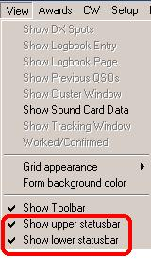

SB_1

2.0 UPPER STATUS BAR

The Upper Status Bar displays five panels of specific information for any callsign entered in the Logbook Entry window. These panels consist of:

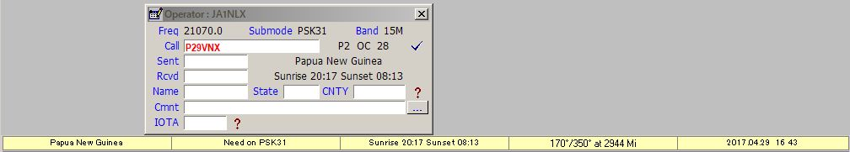

SB_2

2.1 The Country panel

Displays the country name of the contact.

2.2 The Confirmed Panel

If you place the cursor over the Confirmed panel, a yellow pop-up hint box will display the confirmed status of the country.

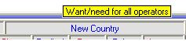

SB_25

2.3 The Sunrise and Sunset Times Panel

If you place the cursor over the Sunrise and Sunset times panel, a yellow pop-up hint box will display your local times.

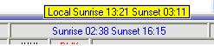

SB_26

2.4 The Beam Headings Panel

Displays the Short and Long path beam headings and Short Path distance to the station. The ADIF spec specifies DISTANCE will be in Km. and this is what is output to the ADI file. However, the logbook will show Miles, NMi or Km depending on the user-setting found in "My QTH Lat'Long". The values in the logbook will re-calculate automatically if the basic distance unit is changed.

If you place the cursor over the Beam Headings panel, a yellow pop-up hint box will display both path headings and distances.

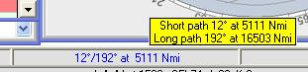

SB_27

2.5 The Date and Time Panel

Displays local date and time at the station, including "polar day" and "polar night" for locations with 24 hour daylight or darkness.

If you right-click on the Date and Time Panel while information is being displayed, complete details for the Time Zone of the selected station will be displayed.

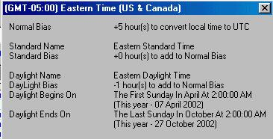

SB_3

Note: The above details will show as displayed when you manually input a callsign into the Logbook Entry window. They will also display following a click on the Logbook Page window highlighting a particular QSO provided that the Worked/Confirmed window is active. If the Worked/Confirmed window is not active, then no details will show when using this alternative method.

3.0 LOWER STATUS BAR

The Lower Status Bar displays general system and status information.

new SB_4

The system and status information displayed in the Lower Status Bar consists of:

3.1 Logger32 Date and Time Panel

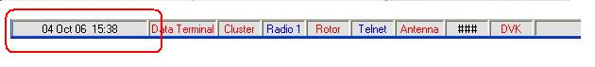

SB_5

If you place the cursor over the Logger32 date and time, a yellow pop-up hint box will display your PC system date, time and time zone.

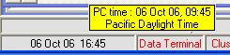

SB_6

If you right-click on the Logger32 date and time, a pop-up menu will be displayed,

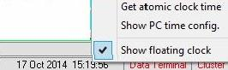

SB_7

allowing you to set your PC time to an Atomic Clock standard or to view details of your PC Time Zone using the same display as described above for the Upper Status Bar local date and time.

Placing a check mark on the Show floating clock menu item, a small Floating Clock will open. This clock can be configured and placed anywhere on the display for a quick reference in local or UTC time.

Right click on the clock pane and a menu will open allowing the user to configure the clock. The show time only option will display the time without the date.

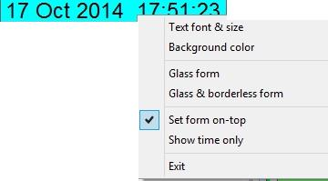

SB_7A

3.2 Data Terminal Window Status

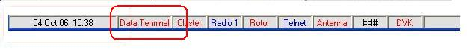

SB_8

If you place the cursor over the Data Terminal Window status, a yellow pop-up hint box will display the current status

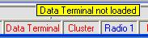

SB_9

3.3 Cluster Window Status

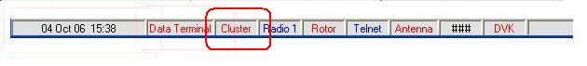

SB_10

If you place the cursor over the Cluster window status, a yellow pop-up hint box will display the status of the serial (COM) port configured for the Telnet Cluster window.

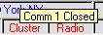

SB_11

If you right-click on the Cluster status, a pop-up menu will be displayed allowing you to open or close (toggle) the serial (COM) port configured for the Telnet Cluster window.

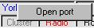

SB_12

3.4 Radio Control Status

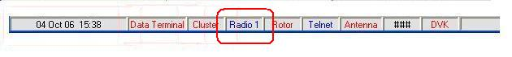

SB_13

If you place the cursor over the Radio control status, a yellow pop-up hint box will display the status of serial (COM) port configured for the Radio port.

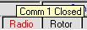

SB_14

If you right-click on the Radio control status, a pop-up menu will be displayed providing a number of choices.

3.5 Rotor Control Status
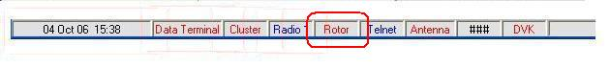

SB_15

If you place the cursor over the Rotor Control status, a yellow pop-up hint box will display the status of the Rotor.

3.6 Telnet Window Status

SB_16

SB_16A

If you place the cursor over the Telnet Window or Local Host status pane, a yellow pop-up hint box will display the status of the socket connection.

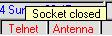

SB_17

If you right-click on the Telnet or Local Host window status, a pop-up menu will be displayed allowing you to connect or disconnect from the Default Remote Host configured in the Telnet Cluster window and Local Host window.

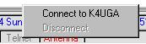

SB_18

3.7 Antenna Selector Status
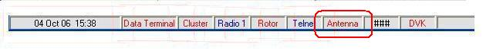

SB_19

If you place the cursor over the Antenna Selector status, a yellow pop-up hint box will display the status of the parallel port configured for the Antenna Selector.

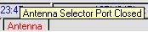

SB_20

3.8 Serial Number

See the Contest Serial Numbers topic.

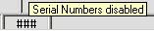

SB21

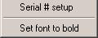

SB_22

3.9 Digital Voice Keyer (DVK) Status
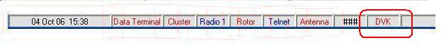

SB_23

If you place the cursor over the DVK status, a yellow pop-up hint box will display the status of the serial (COM) port configured for the DVK port.

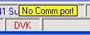

SB_24

3.10 microHAM (uHAM) Status

If you place the cursor over the uHam status, a yellow pop-up hint box will display the status of the serial (COM) port configured for the microHam port.

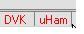

SB_28

3.11 TCP Server status

The TCP Service Status pane displays the current state of the TCP Server port. If the port is opened the caption is highlighted in blue. If the port is closed the caption is highlighted in red .

If you place the cursor over the TCP pane a yellow pop-up hint will display the TCP server status。

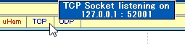

new SB_29

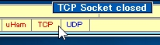

new SB_30

Right click on the TCP pane to display the TCP Server menu.

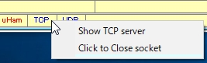

new SB_31

3.12 UDP H2S BandMap status

The UDP H2S BandMap status pane shows the current statte of the UDP H2S BandMap. If the socket is opened then the caption is highlighted in blue. If the socket is closed then the caption is highlighted in red. If you place the cursor over the UDP H2S BandMap pane a pop-up hint will display the UDP TH2S BandMap status.

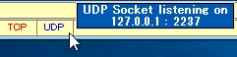
new SB_32

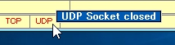
new SB_33

Right click on the UDP H2S BandMap pane to display the UDP H2S BandMap menu.

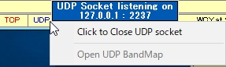

new SB_34

3.13 WWV and WCY Messages Received in the Cluster Window

If you right-click on this pane you will connect to a NOAA website and collect the latest geophysical alert information.

